



SWIGGY DATA ANALYSIS

By: Tarana Parween



Introduction

The online food ordering market includes foods prepared by restaurants, prepared by independent people, and groceries being ordered online and then picked up or delivered. The first online food ordering service, World Wide Waiter (now known as Waiter.com), was founded in 1995. Online food ordering is the process of ordering food from a website or other application. The product can be either ready-to-eat food or food that has not been specially prepared for direction consumption.



Objective

Objective:

In the world of rising new technology and innovation, Food industry is advancing with the role of Data Science and Analytics. Data analysis can help them to understand their business in a quiet different manner and helps to improve the quality of the service by identifying the weak areas of the business.

Benefits:

* Help out to make better business decisions.
* Help analyze customer trends and satisfaction, which can lead to new and better products and

services.

* Gives better insight of customers base.
* Helps in easy flow for managing resources.



Problem Statement

Food industries are having important reflection of the economy from past few decades. Online food ordering is the process of ordering food from a website or other application. The product can be either ready-to-eat food or food that has not been specially prepared for direction consumption.

In this project, we are analyzing the various aspects with different use cases which covers many aspects of Swiggy Food Delivery Service. It helps in not only understanding the meaningful relationships between attributes, but it also allows us to do our own research and come-up with our findings.



**1. Distribution of 'Rating':**

## Chart, histogram Description automatically generatedConclusion:

* + - From this **Distribution Plot**, We can conclude that ***More that '50%' of Restaurants*** are having a ***Rating*** greater than **"4.1"** with a ***Maximum Rating*** of **"4.8"** which is considered as a decent Rating.
    - And It also means that, Most of these Restaurants are doing very well & Rated accordingly by the Customers.



**2. Area-wise Analysis on ‘Rating’ and ‘Cost_for_Two (₹)’ :**

* **BTM Area:**

# Conclusion:

* + 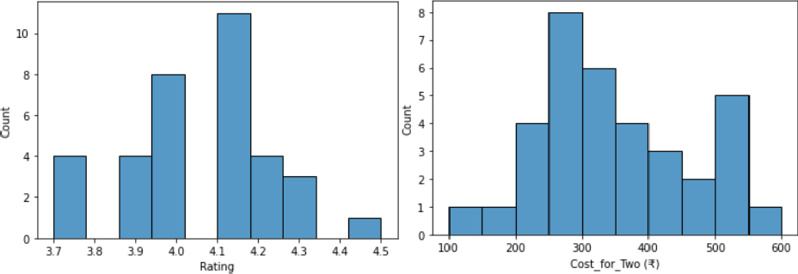From this, you can produce Various Conclusions like –
  + **BTM**: Most has **4.0** to **4.2** Rating and Approx. Cost for Two People lies between **200** to **350**. (Max. Cost goes upto **600**)



**2. Area-wise Analysis on ‘Rating’ and ‘Cost_for_Two (₹)’ :**

* **HSR Area:**

# Conclusion:

* + 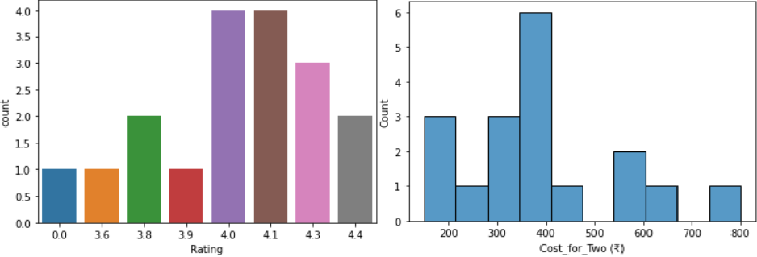From this, you can produce Various Conclusions like –
  + **HSR**: Most has **4** or above Rating and Approx. Cost for Two People lies between **300** to **400**. (Max. Cost goes upto **800**)
* **Koramangala Area:**

1. **Area-wise Analysis on ‘Rating’ and ‘Cost_for_Two (₹)’ :**
   * **Conclusion:**
     + 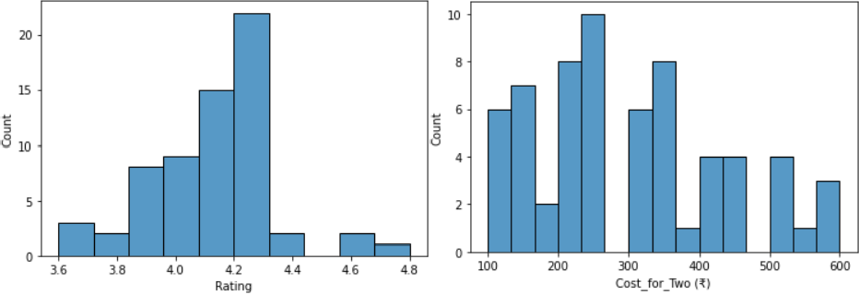From this, you can produce Various Conclusions like –
     + **Koramangala**: Most has **4.0** to **4.3** Rating and Approx. Cost for Two People lies between **200** to **350**. (Max. Cost goes upto **600**)



* With this we can conclude the Most Costly Area is **HSR**.



**3. Analyse "Approx Cost of 2 People" vs "Rating". Find out the relationship between them:**

## Chart Description automatically generatedConclusion:

* + - ***Most of the Affordable/Budgeted Restaurants*** are having ***Excellent Rating*** as well.
    - Same we can see, For ***Approx.***

***Cost*** of **"200", "150", "250"**, and **"450"**,

the ***Ratings*** were **"4.8", "4.6"**,

and **"4.5"** respectively.

* + - This might be because ***Most of the people***

***prefer Affordable/Budget- Restaurants*** which also provides ***good quality*** of ***Cuisines***.

* + - and On the other hand, There are ***few Expensive Restaurants*** who ***doesn't*** have that much ***Rating*** and they are ***Expensive***.
    - ***Restaurants*** which ***Costs*** around **"600"** to **" 800"** for ***Two People*** are having the ***Ratings in between '4.0' to '4.1'*** which is ***too less*** as compared to ***Affordable/Budgeted Restaurants***.



**4. Analyze Affordable/Budgeted and Highest Rated Restaurants of Bangalore:**

## Chart, bar chart Description automatically generatedConclusion:

* + This beautiful **"**Bar Chart**"** displays all the Affordable/Budgeted and Highest Rated Restaurants available in the entire Bangalore Area.



**5. Top 15 Cheapest & Highest Rated Restaurants with Approx. Cost for 2 People:**

### Graphical user interface Description automatically generated with medium confidenceConclusion:

* + This beautiful **"**Bar Chart**"** displays all the Cheapest and Highest Rated Restaurants available in the entire Bangalore Area with Approx. Cost for Two People.



**6. Top 15 Expensive & Highest Rated Restaurants with Approx. Cost for 2 People:**

### Graphical user interface Description automatically generatedConclusion:

* + This beautiful **"**Bar Chart**"** displays all the Expensive and Highest Rated Restaurants available in the entire Bangalore Area with Approx. Cost for Two People.



**7. Cuisines Overall Analysis (Bangalore):**

**Cuisines Analysis -**

**8. Overall Distribution of Cuisines in Bangalore**

**Restaurants:**

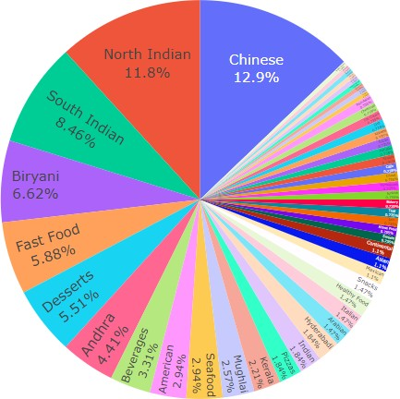

* 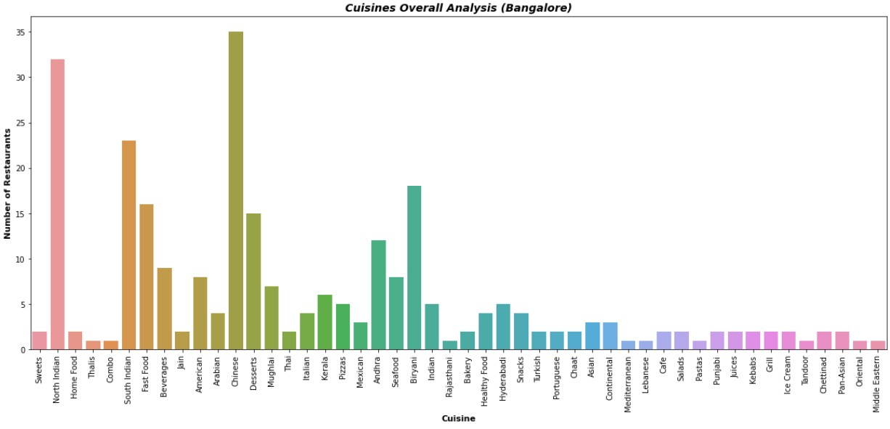**Conclusion:**
  + From the above Visualizations, We can say, ***Most of the Restaurants*** sell **"Chinese"** which is around **'12.9%'** followed by **"North Indian"** & **"South Indian"** Cuisines which are around **'11.8%'** & **'8.46%'**.
  + So, We can also infer that Most of the people are fond of these Cuisines.



**Area-wise Cuisines**

**Analysis -**

**9. Cuisines Analysis – BTM (Bangalore): 10. Distribution of Cuisines in BTM Bangalore**

**Restaurants:**

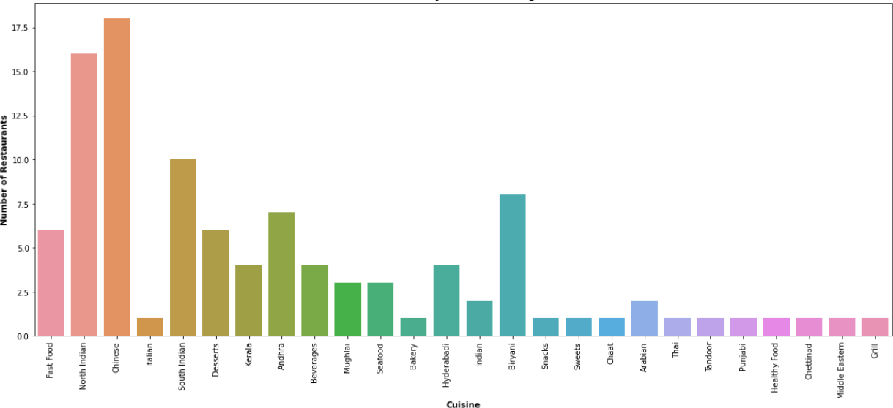 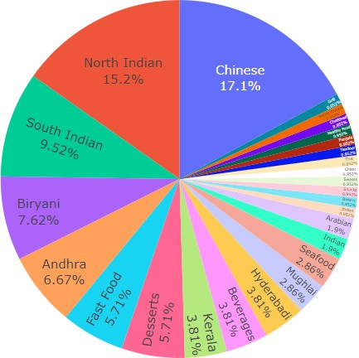

* **Conclusion:**
  + From the above Visualizations, We can say, In **BTM** Area, ***Most of the Restaurants*** sell **"Chinese"** which is around **'17.1%'** followed by **"North Indian"** & **"South Indian"** Cuisines which are around **'15.2%'** & **'9.52%'**.
  + So, We can also infer that Most of the people are fond of these Cuisines.



**Area-wise Cuisines**

**Analysis -**

**11. Cuisines Analysis – HSR (Bangalore): 12. Distribution of Cuisines in HSR Bangalore**

**Restaurants:**

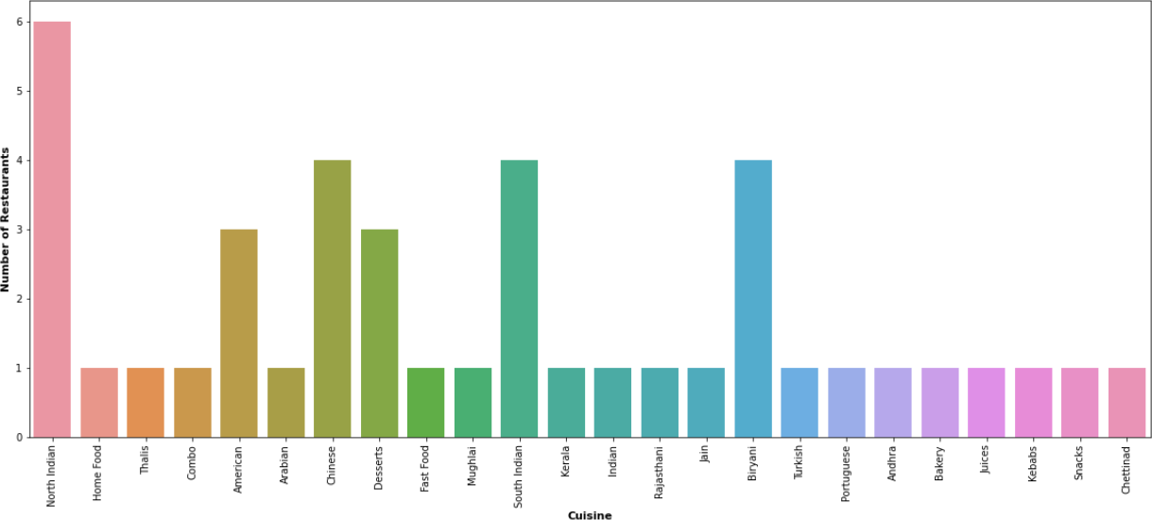 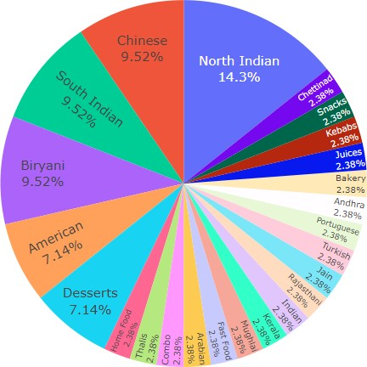

* **Conclusion:**
  + From the above Visualizations, We can say, In **HSR** Area, **"North Indian"** Cuisines are dominated by around **'14.3%'** followed by **"Chinese"** & **"South Indian"** Cuisines **'9.52%'** & **'9.52%’** of Restaurants respectively.
  + So, We can also infer that - In HSR Area, We may have more **"North Indian"** people staying there.



**12. Cuisines Analysis – Koramangala (Bangalore):**

**Area-wise Cuisines**

**Analysis -**

**13. Distribution of Cuisines in Koramangala**

**Bangalore Restaurants:**

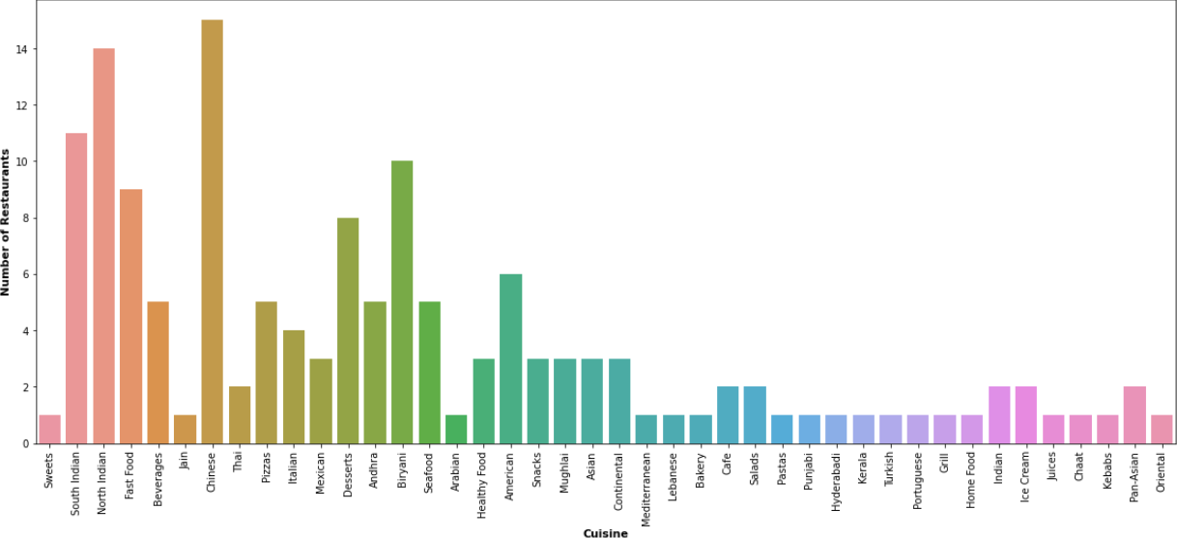 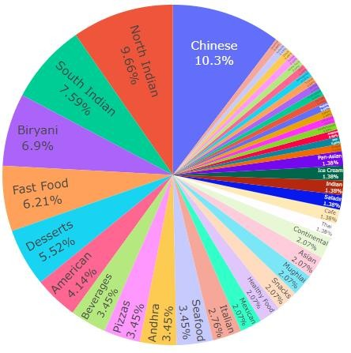

* **Conclusion:**
  + From the above Visualizations, We can say, In **Koramangala** Area, **"Chinese"** Cuisines are dominated by around **'10.3%'** followed by **"North Indian"** & **"South Indian"** Cuisines **'9.66%'** & **'7.59%’** of Restaurants respectively.
  + So, We can also infer that Most of the people are fond of the **"Chinese"** Cuisines.



**14. Most preferred Cuisines by the Customers :**

## A picture containing text, newspaper Description automatically generatedConclusion:

* + - * This beautiful **“**WordCloud**"** displays the Most preferred Cuisines by the Customers all over the Bangalore.





Thank You,

Tarana Parween